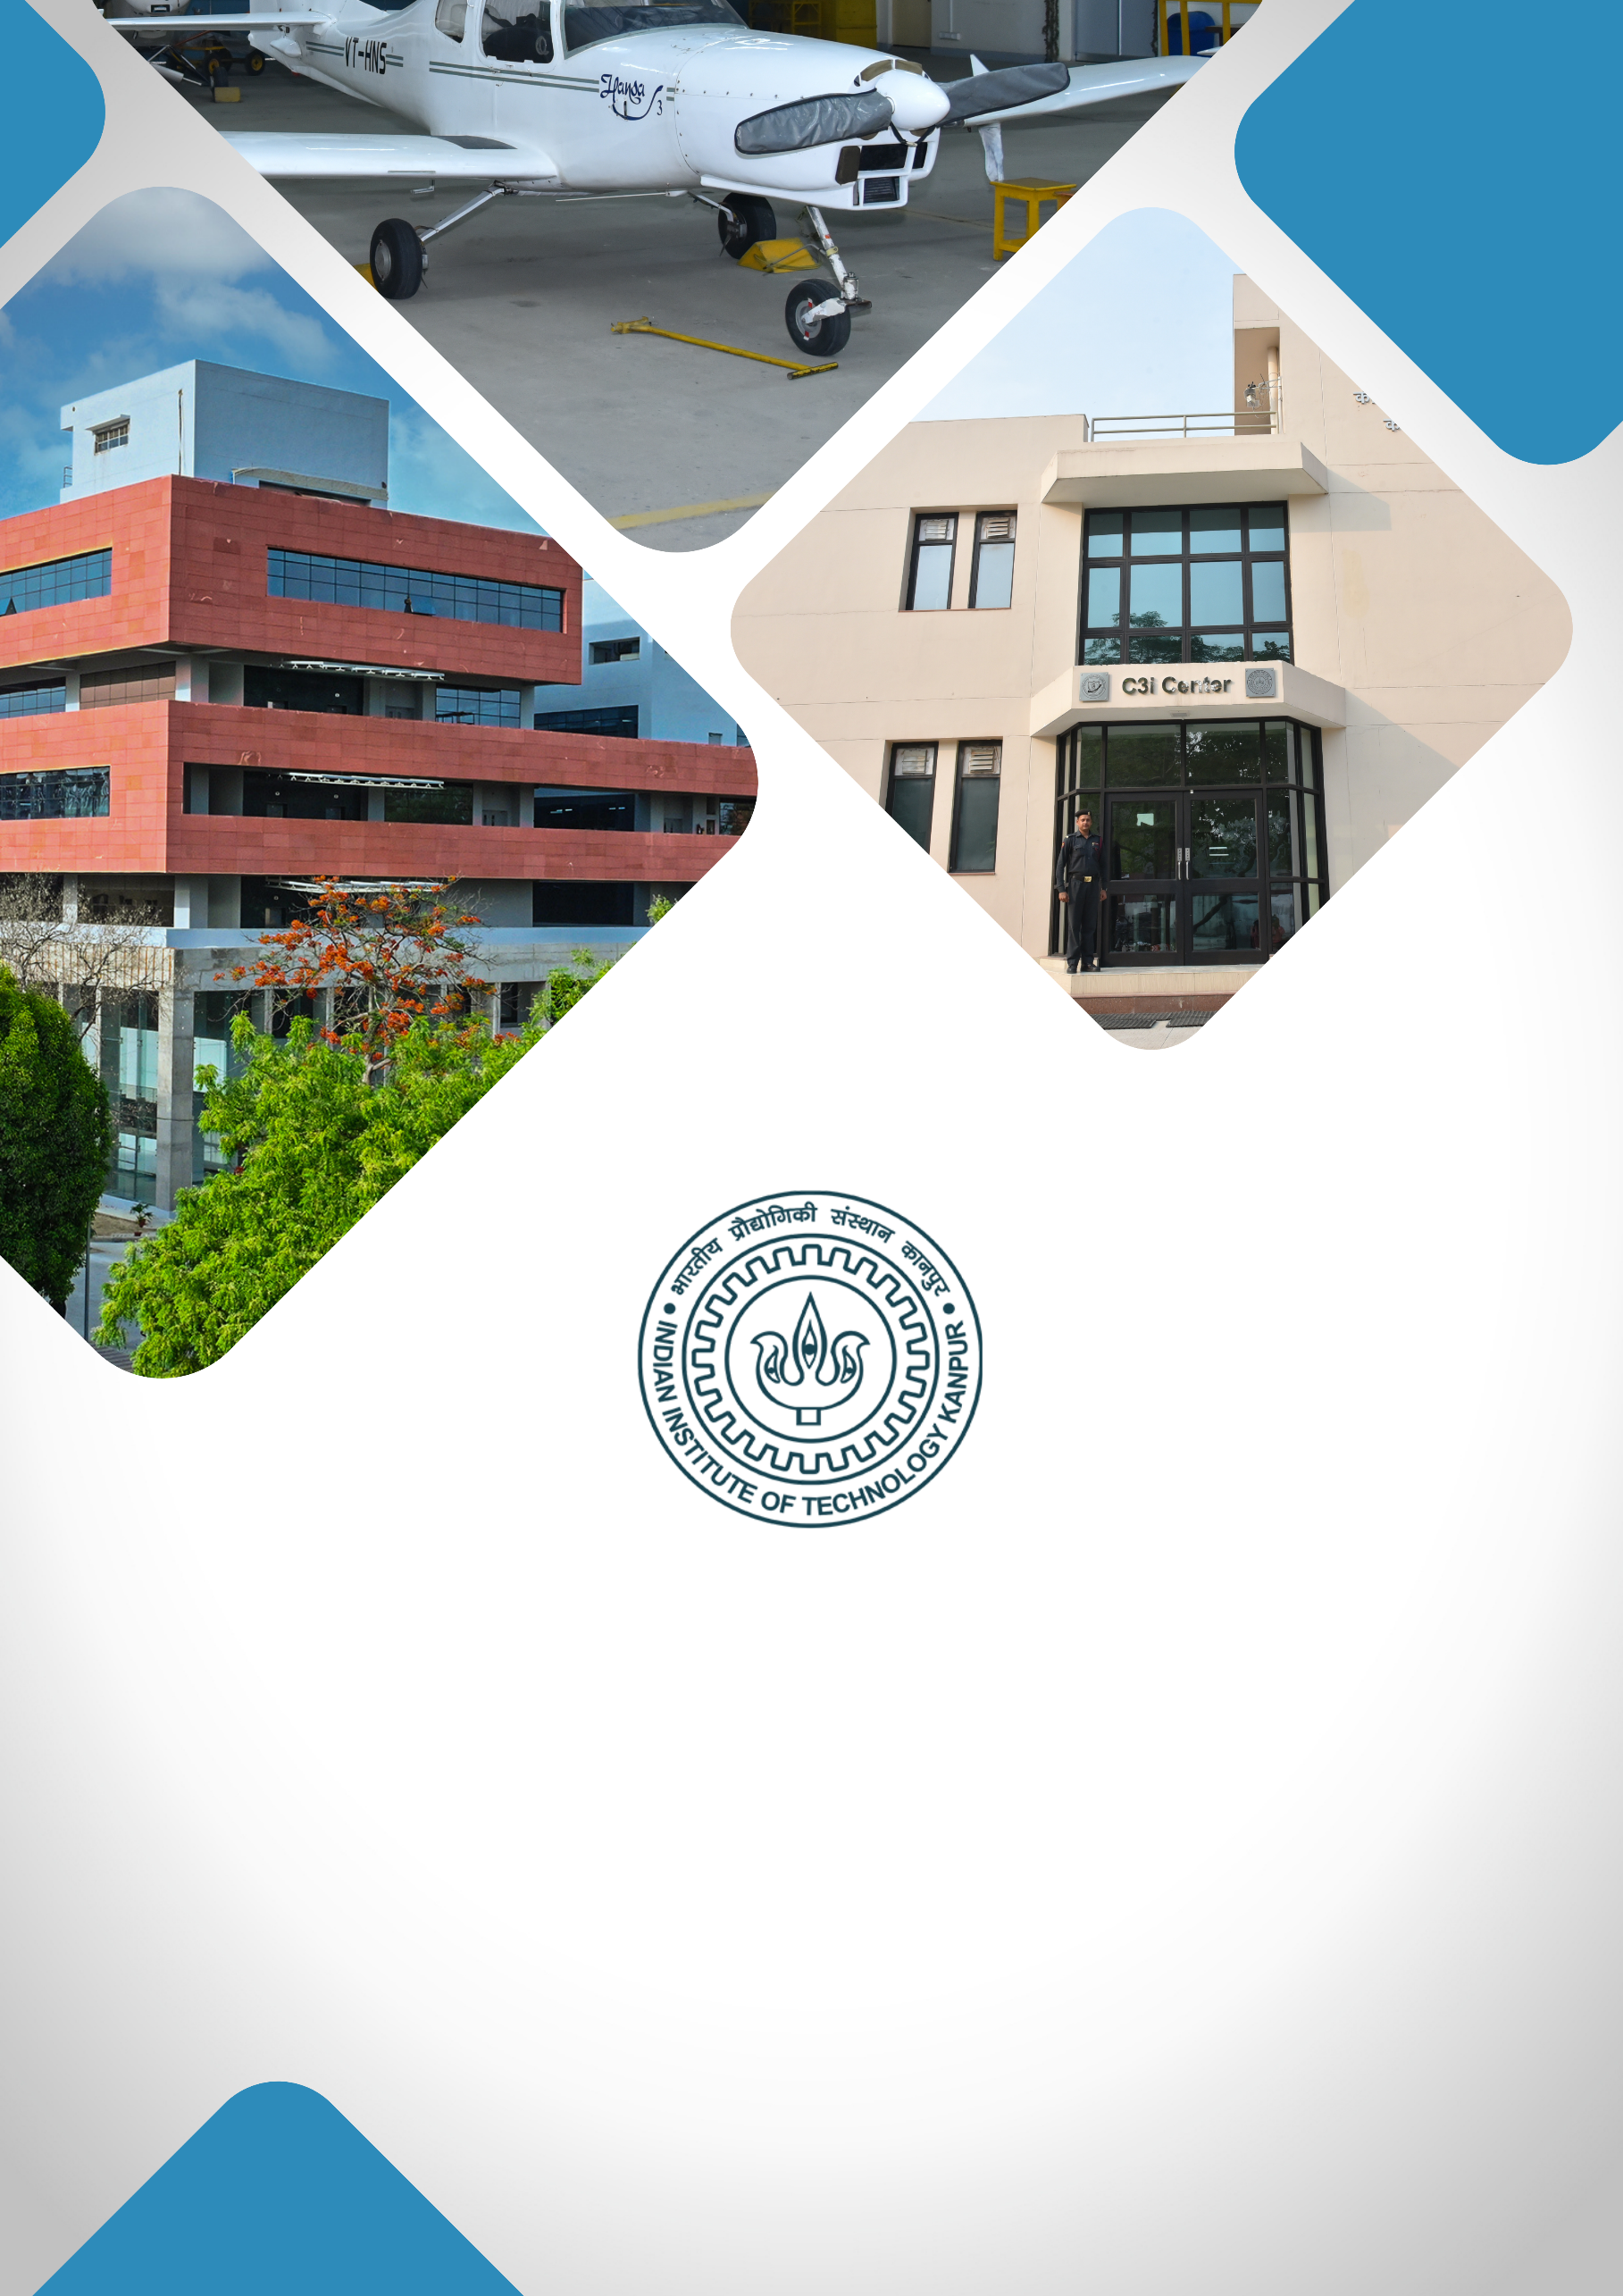

**QUANTUM TECHNOLOGY CENTER**

**TABLE OF CONTENTS**

1. **About IIT Kanpur**
2. **Institutional Vision**
3. **Project Title**
4. **Executive Summary**
5. **Background & Rationale / Motivation**
6. **Project Objectives**
7. **Expected Outcomes**
8. **Expected Impact**
9. **Milestones & Implementation Timeline**
10. **Financial Budget**
11. **Team Involved / Key Faculty Members**

**ABOUT IIT KANPUR**

**Indian Institute of Technology Kanpur**, established in 1959, is one of the premier institutions established by the Government of India. The aim of the Institute is to provide meaningful education, conduct original research of the highest standard, and provide leadership in technological innovation. The Institute has gained a legendary reputation in the country through its academic, social, and economic contributions. The combined record of its past and present faculty and students along with the alumni spread across the world is awe-inspiring.

From the start, the students have been provided education with a strong emphasis on the fundamentals of science and engineering and their application in the field of study. Subsequently, programs in humanities, management, and several interdisciplinary programs like design, environmental engineering and management, material sciences, nuclear engineering and technology, and photonic sciences and engineering programs were started. The education imparted to the students has stood by them even as they acquired new skills and knowledge during their professional careers.

IIT Kanpur continues to be a much sought-after destination for UG and PG studies. In the 65 years of its existence, over 43,000 students have graduated from the Institute. The alumni of IIT Kanpur have made their alma mater proud through their achievements and contributions in diverse fields like engineering, academia, business, entrepreneurship, and public service.

The Institute today has close to 600 full-time faculty members and all of them have earned their degrees from the top universities in the world. The Institute faculty members have often been bestowed with prestigious national honours as listed below:

|  |
| --- |
| Padma Shri |
| Infosys Prize (Infosys Science Foundation) |
| J C Bose Fellowship |
| Shanti Swarup Bhatnagar Prize for Science & Technology |
| Fellow, Indian National Science Academy (INSA), New Delhi |
| Fellow, Indian Academy of Sciences (IAS), Bangalore |
| Fellow, Indian National Academy of Engineering (INAE), New Delhi |
| Fellow, The National Academy of Sciences, India (NASI), Allahabad |
| Fellow, The World Academy of Sciences (TWAS), Italy |
| Humboldt Research Award |
| TWAS Prize |
| Wellcome Trust/India Alliance Early Career/Intermediate/Senior Fellowship |
| Tata Innovation Fellowship |

The Institute has a large pool of academic resources spanning 19 departments, 25 centers, and 3 Interdisciplinary programs in all engineering, science, design, humanities, and management disciplines. It has a student strength of more than 9000 across all programs.

IIT Kanpur has always laid strong emphasis on new academic initiatives that will allow the Institute to broaden its academic repertory and create an impact in academia and society. Some of these initiatives include the Department of Sustainable Energy Engineering and the Department of Cognitive Science which were established in the year 2020.

**INSTITUTIONAL VISION**

***"To create, disseminate, and translate knowledge in science, engineering, and allied disciplines that will best serve society."***

1. **Developing Technologies that Solve Real-World Problems:** Prioritising research and development that address critical societal challenges, translating innovations into solutions with high-TRL (Technology Readiness Level) technologies. The goal is to establish an Office of Translational Research within the Directorate for strategic guidance, funding support, industry connections, and information on government and industry needs.

**Major focus areas:**

* **Large-Scale AI Deployment**: Implementing AI solutions on a wide scale, focusing on impactful applications for government and industry sectors, including public grievance redressal and fraud detection.
* **MedTech:** Making healthcare accessible and affordable through cutting-edge research, device innovation, and medical training with the **Mehta Family Center**, **MedTech IITK**, and the **Gangwal School of Medical Sciences & Technology**.
* **Cybersecurity:** With **C3iHub**, focused on developing advanced solutions, supporting startups, and offering specialised training for critical cybersecurity needs.
* **Unmanned Aerial Vehicle (UAV) Technology**: Advancing UAV technology with a focus on defence, humanitarian, and disaster relief applications, and providing affordable testing facilities to promote industry growth.
* **Sustainability:** Positioning IIT Kanpur as a leader in sustainable development through technologies and initiatives led by the **Kotak School of Sustainability**, the **Chandrakanta Kesavan Centre** **for Energy Policy and Climate Solutions**, and the **Department of Sustainable Energy Engineering**.

1. **Elevating R&D Excellence:** Focus on recruiting top talent, creating state-of-the-art facilities, securing substantial research grants, and maintaining a balance between research quality and quantity.
2. **Enhancing Teaching Quality:** Achieving leadership inhigh-quality education by establishing a Centre for Teaching Excellence, developing courses in soft skills and technical writing, and introducing faculty career paths that focus on research, translational projects, or teaching.
3. **Enhancing Student Life and Campus Infrastructure:** Upgrading existing hostels and constructing new ones to accommodate growing student numbers. Developing state-of-the-art infrastructure within the campus.

**PROJECT TITLE**

**“QUANTUM TECHNOLOGY CENTER @ IIT KANPUR”**

**EXECUTIVE SUMMARY**

Quantum-enhanced technologies hold promises to revolutionize performance and efficiencies of devices for computation, communication, sensing, imaging and metrology for a range of diverse applications. A distinguishing feature of such technologies is the inherent hybrid nature of the finished devices. Such hybrid devices utilize quantum states, prepared from a range of real physical systems that may otherwise differ widely in terms of their functionality and mode of operations. This necessarily requires state-of-art facilities and expertise in multiple domains working in sync to create deliverable quantum technology systems.

Clearly, all these three domains are highly technical and require building expertise and the necessary eco-system that promotes and provides active support at a fundamental level. The best of device technologies from multiple domains which operate on the forefront of near-ideal classical performance needs be redesigned and rethought to provide the “quantum enhanced performance”. In addition, there are potential avenues wherein a completely new “quantum only” designs are envisaged for hitherto deemed impossible technological solution.

To begin with, the QTC@IITK would build the required technological base that focusses on and provides leadership in the following quantum technology platforms.

* **Quantum computation**
* **Quantum imaging**
* **Quantum sensing and metrology**
* **Quantum communication**
* **Quantum Materials**
* **Quantum Algorithms**

**BACKGROUND & RATIONALE / MOTIVATION**

India is marching towards progress and prosperity, with leadership in several emergent technological domains across the country. One such emergent technology that can play a significant disruptive role is quantum technologies that promise unprecedented sensing capabilities, computation powers and fully secured communication. In synchrony with this vision, here we propose to develop a unique, cutting-edge quantum technology at IIT Kanpur that would place IIT Kanpur at the center stage of the quantum revolution nationally and globally.

Quantum sensors, communication and technologies are poised to be the next mega technological revolution that would result in a disruptive change in a variety of domains including governance, agriculture, logistics, healthcare, security, finance, education, and human resource development. Establishment of a one-of-a-kind Center for Quantum Technology at IIT Kanpur (QTC@IITK) domain will not only provide the necessary impetus for preparing human resource, ushering innovations but also will place the institute firmly as leader in this new technological revolution.

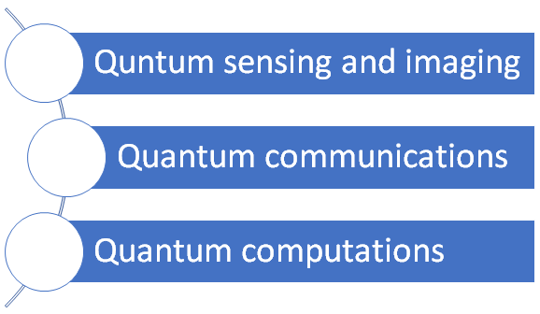

The proposed center is designed to be unique in the country, with all the essential hardware and software development units that are critical for the complex multi-disciplinary nature of requirements of quantum technologies, in one place. Focus has been given on planning for an ambience that would usher seamless, direct collaborations and partnership between academia, industry, and the government partnership. This would be achieved through development of a platform involving hardware/software support ecosystem for all aspiring quantum technologists. Furthermore, a significant focus of the center would be in developing a highly skilled workforce, trained specifically in quantum technologies to provide world-class services and take up leadership roles in UP and the nation at large.

Overall, the proposed center will place IIT Kanpur in a thought leadership role along with the necessary infrastructure required to innovate in quantum technologies towards computation, communication sensing with unprecedented precision.

**PROJECT OBJECTIVES**

At present, the potential next generation quantum technologies can be divided into three broad verticals:

* **Quantum imaging, sensing, and metrology**
* **Quantum computation**
* **Quantum communication**

In the last 30 years, although several scientific and technological advances have already been made in each of these three domains, the major breakthroughs have come mostly in the domains of quantum computation and communication, with the USA leading the quantum computation efforts while China taking a major role in the quantum communication domain. However, as far as technology readiness in concerned, the domain of quantum imaging, sensing and metrology is still in its nascent stage but has huge potential.

**EXPECTED OUTCOMES**

The long-term goal of QTC@IITK is to bring together all the above through quantum algorithms and control protocols for eventual field deployment of the eventual Quantum technology systems. Overall, the QTC will be focused on specific, achievable goals and targeted objectives.

**Deployable Quantum Technologies**

* On demand sources of (i) single photons, (ii) multi-photons, (iii) true random numbers.
* Developing superconductors combined with novel quantum material based high efficiency devices for storing and manipulating quantum information and low photon count detector devices.
* Quantum-enhanced measurement devices for measuring frequency, magnetic field, displacement, and acceleration.
* Quantum-enhanced devices for imaging and communication in turbulent and scattering environments.
* High-efficiency broadband detectors for the orbital angular momentum of photons.
* Fiber-based local area quantum key distribution (QKD) network at 1550 nm band for financial networks.
* Development of long-lived quantum memories and decoherence-free subspaces for quantum computation.
* Research outcomes of the QTC would have the potential for wide scale deployment and testing for enhancement of high-end technology for public good as well as commercialization that will enhance industry-academia collaboration.

**Outreach and training**

The QTC@IITK will aid in the development of a sustainable coherent ecosystem for creating technologies with quantum-enhanced functionality. Such an ecosystem would enable outreach components towards public awareness of quantum technologies through teaching labs and courses for students and creating a solid pipeline of highly trained personnel for a career in quantum technology verticals. The sustainability of such an ecosystem is completely dependent on creating a highly trained workforce which will leapfrog this high-end technology deployment across the state and nation. Accordingly, the objectives of QTC@IITK will include:

* Training of several postdoctoral fellows, PhD students and undergraduate students in the broad area of quantum technology.
* High-impact journal publications along with several PhD thesis in the broad area of quantum information and technology.
* Development of undergraduate and postgraduate courses in quantum information and related areas.
* Creation of courses and skill-development for practising professional across industry who can benefit from Quantum Technologies.
* Provide enabling platform for interconnect between Academia-Industry-Government through research and skill development.
* Establish a start-up ecosystem in Quantum Technology.

**PROPOSED IMPACT** (SOCIAL / SCIENTIFIC)

The QTC@IITK intends to provide that critical foundation to promote all round development. Accordingly, the vision of QTC@IITK will be to make rapid research advances in the quantum technology domains such as imaging, sensing and metrology that are critical for development of India at the grass root level.  The technologies that are envisaged to come out of this effort will benefit a range of public sectors units, including, health, medicine, agriculture, finance and defence. Quantum technology can potentially contribute to a broad spectrum of domains involving every sector of human endeavour, QTC@IITK intends to take up global leadership position in some of these domains within the next few years.

IIT Kanpur has the reputation of creating world class innovators, engineers, and scientists in most domains of engineering and Science. The QTC intends to leverage this experience and expertise that will attract, train, and deploy the next generation of Quantum Technology engineers. We run a variety of outreach programs that create and nurture young minds in the domains of science and engineering.

The QTC@IITK will become the premier platform for the realization of Quantum Technologies of the future. The Government of India has declared a National Quantum Mission that will support research and Industry across the country to the tune of INR 6000 Crores. To sustain and provide continuous support for this state-of-the-art innovation facility in the Quantum domain the team at QTC@IITK would seek funding from the government under the aegis of the National Quantum Mission. Our task would be to continuously expand the activities of the center to take up newer challenges in this domain. We will also seek financial support from industry in these technologies of the future.

**MILESTONES & IMPLEMENTATION TIMELINE**

The activities envisaged by the QTC@IITK are technologically intensive. This require setting up of the multifarious state-of-the-art research platforms and facilities housed under one roof, high-end research equipment, well-equipped training and outreach center and highly skilled technical and administrative staff members to facilitate the above.

* **A dedicated building for setting up QTC@IITK**

The envisaged activities of the QTC@IITK require specialized dedicated spaces to house the state-of-the-art facilities. The center will house 15 research laboratories, 9 technical, design and fabrication facilities, a few high-end industry-supported research and development facilities, a training and outreach hub, meeting and conference rooms and offices.  A budget of about INR 25 Crores is essential to set up this 5000 square-meter center.

* **15 Research laboratories**

These laboratories will house various project-focused experimental facilities, across the whole range of physical systems, such as cold-atoms facility, ion-traps, photonics in both fiber and turbulent atmosphere, superconducting qubit facility, opto-mechanical systems, neutral-Atom trapping systems, quantum chip laboratory, 2D-materials laboratories, quantum networks laboratory and topological systems laboratory. Some laboratories will be earmarked for new faculty member recruits to initiate state of the art facilities in this rapidly evolving field. We would be able to initiate many of these projects with an initial support of INR 45 crores.

* **9 State of the Art technical, design and fabrication facilities**
* Electronic design and testing facility
* Optical design and testing facility
* Cryogenic facilities
* Microwave and terahertz design and testing facility
* Computing facility for quantum algorithms and control
* Class-1000 clean room for quantum device fabrication facility
* Mechanical design and testing facility
* High-end industry/start-up training laboratory
* Quantum benchmarking laboratory

The estimated budgetary requirement for initiating all the above facilities is INR 75 Crores. Details of individual facilities listed above are provided below in the proposal.

* **Industry supported high-end facilities housed within the Center**

The QTC@IITK envisages multiple industrial partners who will bring in their best-practices manufacturing and design platforms to support translational research in the Quantum domain. For example, industrial houses such as TATA, IBM and Agilent would be invited to financially support and set up testing, design and fabrication facilities. This would also tremendously decrease the timelines for QTC@IITK device development and final products reaching the market.

* **Human Resource**

At the outset the human resources required for the QTC@IITK would involve specialists in each technical domain ably supported by a lean administrative staff support. The above technical ancillary facilities are critical for achieving the scientific goals of the center.  Each facility will require specialized technical personnel to run these highly technical equipment and platforms. The QTC@IITK would hire specialized personnel as well as seek support from the institute to deploy Reseach Establishment Officers to these technical facilities. In addition, administrative support staff will be necessary to manage the day-to-day running of the center. The estimated budgetary requirements would be about INR 10 crores for the next five years.

* **Training and outreach hub**

The Training and Outreach hub is central to creating the next generation of quantum scientists and engineers. The centre will develop undergraduate and postgraduate courses in quantum technologies and related areas with hands-on training in state-of-the art laboratories. In addition, the centre would also support creation of courses and skill-development for practising professional across industry and startups. The estimated budgetary requirements would be about INR 2 crores initially for setting up such a hub.

* **Timelines**

|  |  |  |  |
| --- | --- | --- | --- |
| **Item** | **Year # 1** | **Year # 2** | **Year # 3** |
| Construction of the center building |  |  |  |
| 15 research laboratories |  |  |  |
| 9 State of the ancillary facilities |  |  |  |
| Training and outreach hub |  |  |  |
| Industry-supported high-end facilities |  |  |  |
| Hiring of Manpower |  |  |  |

**BUDGET**

Any other information you may like to give in support of this proposal that may help

evaluate it. (e.g.- High-resolution photographs, videos 1-2 min)

|  |  |  |  |
| --- | --- | --- | --- |
| **S. No.** | **Item** | **Estimated cost  (in INR crores)** | |
| 1 | **A dedicated building for setting up QTC@IITK** | **25** | |
| 2 | **15 Research laboratories** | **45** | |
| 3 | **9 State of the Art technical, design, fabrication and prototyping facilities** | **75** | |
| 3 (i) | Electronic design and testing facility | 09 |  |
| 3 (ii) | Optical design and testing facility | 09 |
| 3 (iii) | Cryogenic facilities | 10 |
| 3 (iv) | Microwave and terahertz design and testing facility | 07 |
| 3 (v) | Computing facility for quantum algorithms and control | 08 |
| 3 (vi) | Class-1000 clean room for quantum device fabrication facility | 10 |
| 3 (vii) | Mechanical design and testing facility | 08 |
| 3 (viii) | High-end industry/start-up training laboratory | 07 |
| 3 (ix) | Quantum benchmarking and testing facility | 07 |
| 4 | **Human Resource (for 3 years)** | **10** | |
| 5 | **Training and outreach hub** | **02** | |
| 6 | **Contingency** | **15** | |
|  | **Total** | **172** | |

**TEAM INVOLVED / KEY FACULTY MEMBERS** (with credentials as below)

|  |  |  |
| --- | --- | --- |
| 1. | Satyajit Banerjee | Physics |
| 2. | Diptarka Das | Physics |
| 3. | Shilpi Gupta | Electrical Engineering & CELP |
| 4. | Saikat Ghosh | Physics |
| 5. | Arnab Ghosh | Chemistry |
| 6. | Anand Kumar Jha | Physics |
| 7. | Pradeep Kumar | Electrical Engineering & CELP |
| 8. | Arijit Kundu | Physics |
| 9. | Rajat Mittal | Computer Science and Engineering |
| 10. | Satyadev Nandkumar | Computer Science and Engineering |
| 11. | G. Rajshekhar | Electrical Engineering & CELP |
| 12. | K Srihari | Chemistry |
| 13. | Tapobrata Sarkar | Physics |
| 14. | Harshawardhan Wanare | Physics & CELP |
| 15. | Venkata Jayasurya Yallapragada | Physics |